
TITLE OF the PAPER
(TWO LINES maximum)
John Smith¹, Kelvin Bose²
¹ University of Nis, Faculty of Occupational Safety, Serbia, e-mail of the first author
² ”Politehnica” University of Timisoara, Faculty of Mechanical Engineering

Abstract - Manuscript typing instructions for authors provide the information about the styles for preparation of the manuscripts that will be submitted to the 26th International Conference “Noise and Vibration”. Your manuscript must be typewritten taking this page as an example, using computed-edited text program Word for Windows. Use only document Instructions2018.doc with predefined styles for typewritten manuscript. This document
can be load from http://www.znrfak.ni.ac.rs/NOISE2018/Index.html.

1. INTRODUCTION
The electronic form of the manuscript (Word and PDF version) should be submitted to the Conference Secretariat by e-mail no later than November 5, 2018:
darko.mihajlov@znrfak.ni.ac.rs
The manuscript must be written in English and should not exceed 8 pages in A4 format including figures, tables, references and illustrations.
The margins of the manuscript should be: top, bottom and left 2cm each, and right 1cm. The manuscript should not end at the beginning of a new page. If the last page of the manuscript is not full, the text should be divided into two columns of the same length.

2. SUBHEADING (E.G. METHODOLOGY)
Use the following styles for manuscript typewriting:
- Title of paper – Paper title (Font: Times New Roman, Bold, All caps, 14pts, Spacing: before – 18pts, after – 6pts, Alignment: centered).
- Name of authors – Author name (Font: Times New Roman, Italic, 12pts, Spacing: before – 0pts, after – 12pts, Alignment: centered).
- The company/institute name and authors' addresses should be typed in the footnotes – Footnote text (Font: Times New Roman, Italic, 10pts, Spacing: before – 0pts, after – 3pts, Alignment: left).
- Abstract at the manuscript beginning – Abstract (Font: Times New Roman, Italic, 10pts, Spacing: before – 0pts, after – 3pts, Alignment: justified). Bold text – Abstract.
- The other part of the manuscript should be typed in two columns spaced with 5mm using the style Normal (Font: Times New Roman, Italic, 10pts, Spacing: before – 0pts, after – 3pts, Alignment: justified).
- Use three levels of headings maximum.– Heading 1 (Font: Arial, Bold, All caps, 10pts, Spacing: before – 12pts, after – 3pts, Alignment: left), Heading 2 (Font: Arial, Bold, 10pts, Spacing: before – 6pts, after – 3pts, Alignment: left), Heading 3 (Font: Arial, BoldItalic, 10pts, Spacing: before – 6pts, after – 3pts, Alignment: left).

2.1 Subheading (e.g. results)
The equations are typed in one column using styles and sizes given in these gudelines and explained in Fig. 1 and Fig. 2. They should be marked at the right margin with formating paragraph using styles – Equation (Font: Times New Roman, 10pts, Spacing: before – 3pts, after – 3pts, Alignment: centered, Tabs: 4.85cm centered, 8.75cm left), such as:
$(\frac{∂n}{∂t})_{x}−V(t)(\frac{∂n}{∂t})_{t}=f−(f+g)n$ (1)
If they are too long, the equations can be typed in two columns.
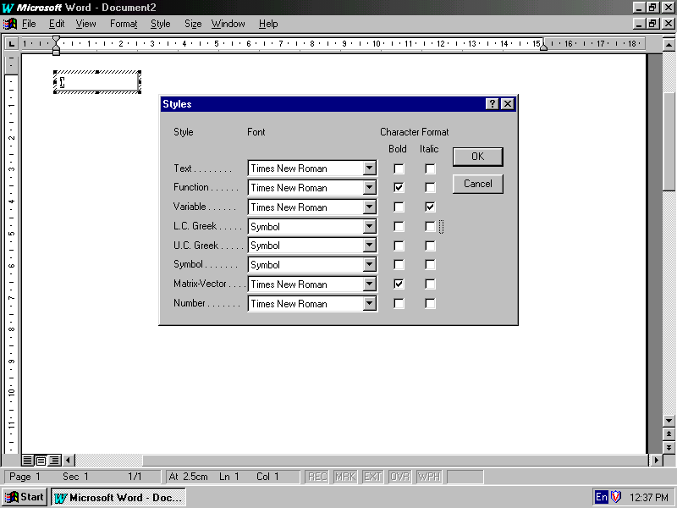
Fig. 1 Font styles for typewriting equation
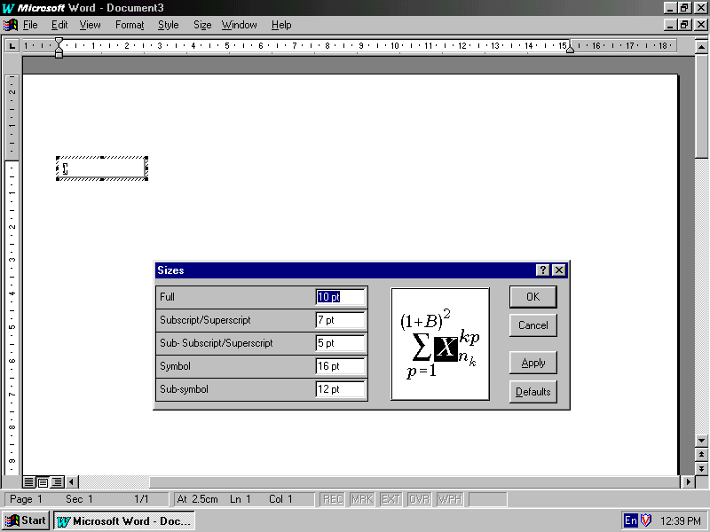
Fig. 2 Font sizes for typewriting equation

2.1.1 Subheading (e.g. conclusion)
Figure captions should be formatted using the style – Picture title (Font: Times New Roman, Italic, 10pts, Spacing: before – 3pts, after – 3pts, Alignment: centered). Bold only sign of figures.
The illustrations (tables, figures, etc.) can be larger than one column. Caption for tables are typed above the tables in the right corner with formatting paragraph using the style Table title (Font: Times New Roman, Italic, 10pts, Spacing: before – 3pts, after – 3pts, Alignment: left). Bold only sign of tables.
Table 2 Results of experiment
x | 1 | 2 | 3
y | 40 | 30 | 20
The paragraphs with the text or other illustrations that are immediately under the figure or table should be additionaly formatted with 6pts spacing before.

references
References are numbered in the order in which they appear (e.g. in [2] is shown...) and are listed at the end of the manuscript. Reference samples:
- V.I. Utkin, "Variable structure control systems with sliding modes", IEEE Trans. Automat. Control, vol. AC-22, pp. 210-222, April, 1977.
- A.E. Bryson and Y. C. Ho, Applied Optimal Control, New York:Wiley, 1975.
- B.K. Bose, “Sliding mode control of induction motor”, in Proc. IEEE Ind. Appl. Soc. Annu. Meeting, 1995, pp. 479-486

